DIS-CAN-Cul- Kwakiutl-"Talking Stick" Final

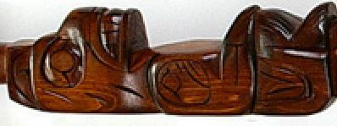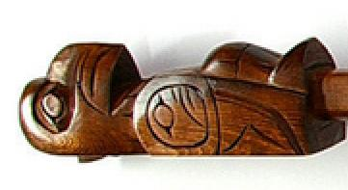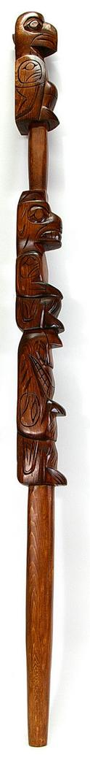 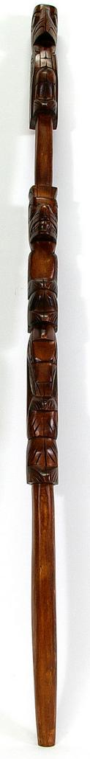 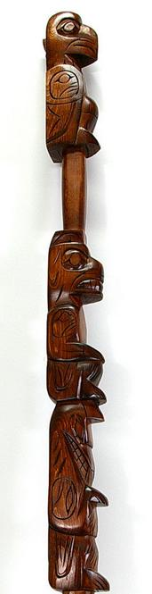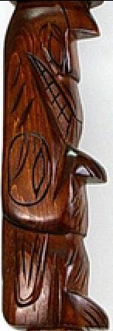

This yellow cedar talking stick by Coast Salish First Nations artist Jim Yelton depicts an 'Eagle', 'Bear', and 'Wolf'. It measures 42" x 2 1/2" x 2 1/2".

The Coast Salish cultures differ from those of their northern neighbors having a patrilineal rather than matrilineal kinship system, with inheritance and descent passed through the male line. Hence, this "Talking Stick" " of the Kwakiutl (Kwakwaka'wakw) of northern Vancouver Island in British Columbia was carved with the chief's crests, similar to those of a totem pole. It was held by a speaker who acted as an intermediary to announce the chief's wishes to the assembled people. Today, anyone who wishes to speak in council must take the talking stick to claim authority and truth of speech much like placing one's hand on the Bible in a court room. Since the "Talking Stick" was the property of the chief it was carved with his crests, similar to those of a totem pole. On this "Talking Stick" the three crests are the 'Eagle', 'Bear', and 'Wolf' referring to friendship, authority and family.

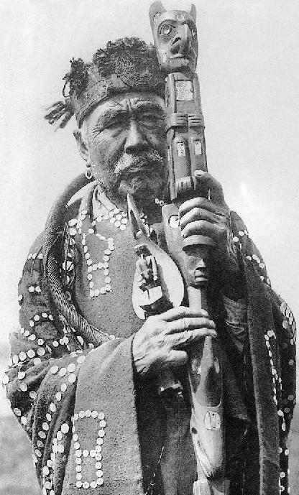

[Hamasoka, Principal Chief of the Kwakiutl Village Qagyhul at Fort Rupert (Curtis 1907-1930, Suppl. v. 10, 1914, pl. 333](http://en.wikipedia.org/wiki/File:Kwakwakawakwtribesman.jpeg).

In this photograph the chief is holding a "Talking Stick" with Bear, an ancestor, and Wolf its crests, and he is wearing a robe signifying his authority and wealth. The robe is adorned with the symbols of a filleted salmon. Salmon geometric symbols are popularly known as a "copper" from the prehistoric past when they were made from float copper that was found beached on shores of Great Lake inlets after winter storms, similar to the "Old Copper" culture, dating to 3000 BCE.

*Tlakwa* signifies "wealth in salmon", since salmon was the measure of status of theKwakiutl, the Tlingittinneh (plate) or yek (metal), the Tsimshian ha’yatask, and the Haida taow.

Geometric symbols of the filleted salmon are also found as petroglyphs and pictographs indicating that the filleted salmon symbols have prehistoric origins.

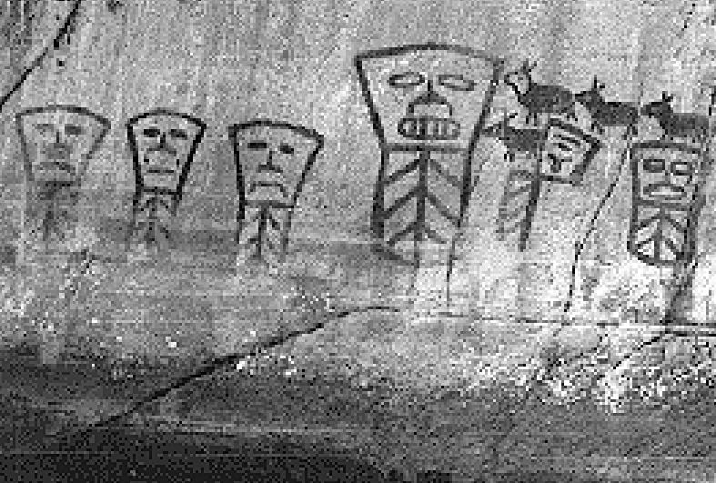

"Coppers" portrayed in pictographs at Petley Point, Kingcome inlet, British Columbia.

https://waikowhai2.files.wordpress.com/2014/01/pictographs.gif

The origin of the "copper" design has been the subject of intense debate but the discovery of prehistoric pictographs at Petley Point, Kingcome inlet, British Columbia (Lat. :  50° 55' 30.1" (50.925°), North Long. : 126°13'48.3" (126.2301) west clearly indicate that the "copper" was meant to symbolize the filleted salmon. The visages that are seen in the upper portion of the "copper" design has anthropomorphic features: eyes, nose and mouth. These anthropomorphic features probably symbolize keepers of "coppers," especially empowered persons economically or spiritually or both unless they transgress certain mores. The largest copper in this pictographic montage has bared teeth suggesting one keeper with greatest power. The figure to its left has a tongue extended and is a partial "copper" that is broken in its upper left and right quadrants, a process of dismemberment that was practiced and recorded in historic times when the gifted "copper" was deemed to have been given to an unworthy recipient and therefore was dismembered to reflect its unworthy recipient, hence, suggesting vanquishment for some infraction.

In the pictograph above the "coppers" appear to be attracting a procession of caribou (the bull in the lead being distinguished by his light mane), and all are being led to the "chief", the most powerful "copper" holder.

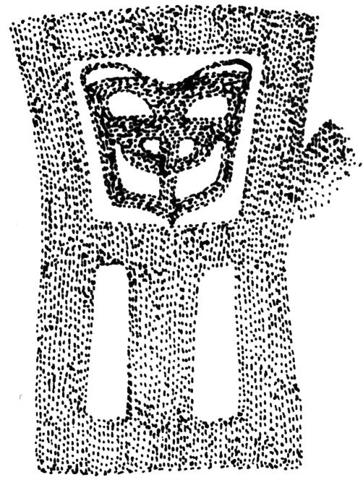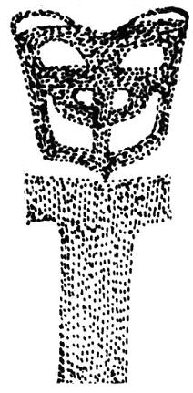

Pictograph from the Fisher Channel area from Fig. 5.3a, Doris Lundy, "Styles of Coastal Rock Art," Ch. 5 in Roy L Carlson, ed., *Indian Traditions of the Northwest Coast* (Burnaby, British Columbia: Archaeology Press, Simon Fraser University), p. 92. Fig. with frame of "copper" removed.

The pictograph from the Fisher Channel area exemplifies the general structure of "coppers with an anthropomorphic mask in its upper quadrant. This may relate to the way "coppers" are connected to the "Talking Stick" since the mask or crest surmounts the design. The mask here clearly represents Bear and seen with the frame of the "copper" removed suggests a Bear crest surmounting a "Talking Stick."

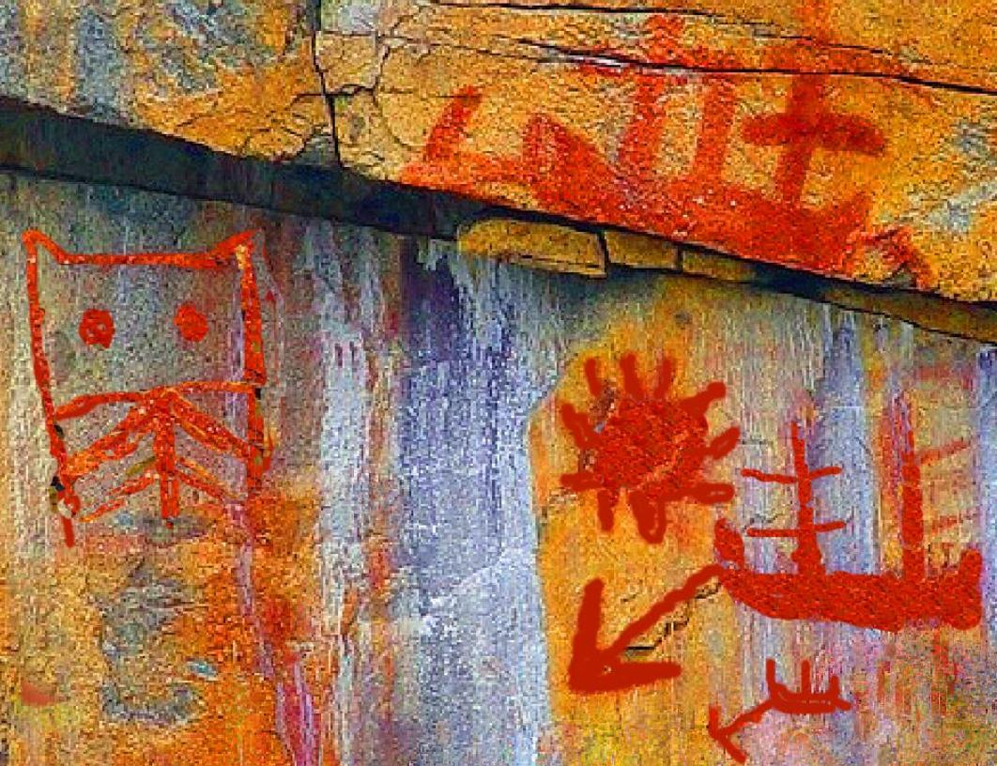

# Order details

Sold by [artfromabove](http://myworld.ebay.com/artfromabove) ( [603](http://feedback.ebay.com/ws/eBayISAPI.dll?ViewFeedback&userid=artfromabove) )

### Delivery package 1 of 1

Estimated delivery Thursday, Oct 8, 2015 - Monday, Oct 19, 2015

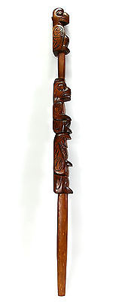

#### [Northwest "Talking Stick" Yellow Cedar Totem Pole Design Native American Staff](http://www.ebay.com/itm/251584843361)

|  |  |
| --- | --- |
| Item price | $330.00 |
| Quantity | 1 |
| Item number | 251584843361 |
| Shipping service | Standard Shipping from outside US |

## Shipping address

Ralph J Coffman Jr

149 Atlantic Ave

Swampscott MA 01907-2427

United States

## Order total

|  |  |
| --- | --- |
| Subtotal | $330.00 |
| Shipping | $50.00 |

**Total**

$380.00